NOBLE PARK ENGLISH LANGUAGE SCHOOL
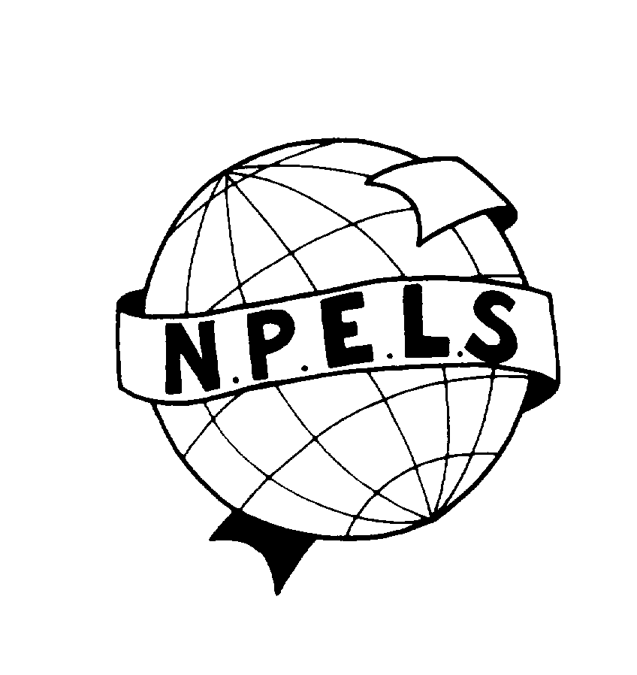
STUDENT ENGAGEMENT & INCLUSION POLICY
This policy reflects the DEECD Student Engagement and Inclusion Guidance and was produced in consultation with the school community.

Every child, every opportunity

Revised August 2014

Principal: Enza Calabro

TABLE OF CONTENTS

- School Profile Statement 3

- School values, philosophy and vision 4

- Guiding principles 5

- Engagement strategies 5

- Identifying students in need of extra support 6

- Behaviour expectations 6

- School actions 6
- Engaging with families 7

- Evaluation 7

- Appendices and Related Policies 9

Appendix 1: Student anti-bullying statement 9
Appendix 2: Statement of rights and responsibilities 15
Appendix 3: Engagement and preventative programs 18
Appendix 4: Student code of behaviour 21
Appendix 5: Behaviour management statement 22
Appendix 6: NPELS Statement of values 24
Appendix 7: Wellbeing referral process 27
- School Profile

Noble Park English Language School comprises four campuses: Noble Park and Casey with both primary and secondary students, and Springvale and Stonnington Glen Eira which have primary students only. The school is staffed by a Principal, Assistant Principals, Leading Teachers including Campus Coordinators, Careers Coordinator, Transition Officers, Outreach Officers and P-10 Coordinator, specialist primary and secondary EAL teachers, wellbeing team, multicultural aides, literacy aides and office staff.

The school’s commitment to multiculturalism underpins all programs at Noble Park English Language School. The school is committed to providing a secure caring learning environment where staff and students respect and tolerate differences between cultures and religions and cater for individual differences in language acquisition. The school provides equal opportunity and access for all students of P-12 age regardless of sex, ethnic background, race, religion, disability or economic status.

The basis of the curriculum is the study of the English language; however, the curriculum also aims to prepare students for life in Australia. Many students have been displaced by war, economic hardship or political persecution. The school is committed to assisting students to regain trust in people and systems and to develop the self esteem and confidence required to face the challenges of a future in a new country.

The school is divided into primary and secondary sectors. In the primary sector students are grouped according to age. In the secondary sector they are grouped according to age and English language proficiency.

Students stay at the school for a period of six to twelve months depending on educational backgrounds. The school population is very transient and there is a totally new student population every twelve months. Many of the students at the school have come to Australia as refugees. This creates added challenges for the staff as they cater for the needs of new students on a week to week basis.

After completing their course, students are assisted to transfer to over 50 mainstream primary and secondary schools and TAFE colleges. A small number of students enter private schools.

The school provides both language and settlement assistance to students and families. There is a broad wellbeing program at the school. Wellbeing and settlement issues are dealt with within the curriculum and extra support is provided as needed within the school. Parents/guardians are actively encouraged to visit the school and participate in a range of activities.

The school has close ties with community services and agencies providing assistance to students and their families. The close relationship with local support agencies is reflected in the structure of the school council. The school council has representatives from the major wellbeing services and ethnic groups in the local community and is focused on recognising and meeting the educational and wellbeing needs of the non-English speaking background community.

- School philosophy, vision and values
Our philosophy:
Noble Park English Language School acknowledges that student wellbeing and student learning outcomes are inextricably linked. Our school has a responsibility to provide an environment that ensures that all students are valued and supported, are able to develop a sense of belonging, and can positively engage in their learning experience.
Our vision:
At Noble Park English Language School newly arrived students are welcomed and supported to gain the English language and learning skills they need to begin their ongoing education and seamless transition to life in Australia.
Our values:
We are committed to our school values of learning, respect, responsibility and safety and these values are embedded in our curriculum and preventative programs. School shared expectations include:
- inclusive teaching practices
- accessible educational provision for all students
- collaboration with parent/carers
- community partnerships which support student engagement and success
- provision of appropriate student services
- access to an appropriate and flexible curriculum that ensures that students have the opportunity to experience success in their learning.

Noble Park English Language School is also committed to preventing and addressing bullying, including cyberbullying. Please see our Anti-bullying policy, processes and student ICT Agreement for more information. See Appendix 1.

A statement regarding the rights and responsibilities of the school community is included at Appendix 2.

- Guiding principles
- Noble Park English Language School will collaboratively develop and implement a fair and respectful whole school engagement and behaviour management approach.
- The school’s curriculum will include pro-social values and behaviour to enable students to acquire knowledge and skills, value diversity and build a culture of learning, community and engagement.
- Noble Park English Language School will promote student engagement and wellbeing by providing a safe, supportive and positive environment, in which students feel comfortable, have a sense of belonging and where all students have the opportunity to experience success.
- The school will support families to engage in their child’s learning and build their capacity as active learners
- The school will establish social/emotional and educational support for vulnerable students and monitor and evaluate progress.
- The school will have processes in place to identify and respond to individual students who require additional assistance and support.
- The school will build strong links with the local community to gain access to an extended network of community members, professionals and educators who can provide expertise and experience that can build the capacity of our school and our teachers to respond to the needs of the students.

- Engagement strategies
Noble Park English Language School has in place a range of strategies and preventative programs to promote engagement, positive behaviour and respectful relationships in the school. We recognise that some students, as a group or as individuals may need extra social, emotional or educational support to flourish at school, and strategies will be put in place to provide them with the support they need.

The school works collaboratively with students, parents/carers to establish fair and respectful behaviour policies and practices, based on the school’s values, expected social competencies and positive peer relationships. There are intervention strategies in place to address inappropriate behaviours which can negatively impact on the learning environment of the self and others.

The school has developed strong links with external agencies and providers to support student engagement and to provide relevant information to students and families. Preventative programs implemented within the school to assist in the goals of improving safety, wellbeing and engagement of all students is listed in Appendix 3.

- Identifying students in need of extra support
Noble Park English Language School will use the following information and tools to identify students in need of extra support using the following strategies:
- Personal information gathered on enrolment
- Attendance rates
- Academic performance and English language acquisition
- Behaviour observed by classroom teacher(s)
- Engagement with student families
Wellbeing referral process is outlined at Appendix 7.

- Behavioural expectations
Shared behaviour expectations for the school community are outlined in Appendix 4 and Appendix 6.

- School actions
It is acknowledged that despite every effort, there will be behaviours and events that occur that run contrary to the school values and goals. When this occurs, the school has adopted a restorative approach, which aims to deal with inappropriate behaviour and attitudes in a positive way. See Appendix 5.

Responding to challenging behaviour
Where a student acts in breach of the behaviour standards of our school community, we will institute a staged response, as outlined in the Department of Education and Early Childhood Development Student Engagement and Inclusion Guidance 2014. http://www.education.vic.gov.au/school/principals/participation/Pages/studentengagementguidance.aspx

Discipline
Disciplinary measures may be used as part of a staged response to challenging behaviour in combination with other engagement and support strategies to address the range of factors that may have contributed to the student’s behaviour.
Disciplinary measures that may be applied include:
- Restorative approach
- Withdrawal of privileges
- Withdrawal from class activities for a specified period. Where appropriate, parents/carers will be informed of such withdrawals
- Time Out
- Suspension (in school and out of school)
- Expulsion
Discipline will be applied in a way that is proportionate to the behaviour and upholds procedural fairness.

Corporal punishment is prohibited in all Victorian schools. Corporal punishment must NOT be used at school under any circumstances.

Suspension and expulsion are measures of last resort and may only be applied when the grounds for suspension and expulsion set out in the Engagement and Inclusion Guidance have been met.
Suspension and expulsion can only be approved by the principal and Noble Park English Language School will follow the processes for applying these disciplinary measures set out in the Student Engagement and Inclusion Guidance 2014.

Information on grounds and processes for suspension and expulsion that our school will follow are available here: http://www.education.vic.gov.au/school/principals/participation/Pages/discipline.aspx

- Engaging with families
The school values parent/carer input into its operations and curriculum offerings and seeks feedback through the Parent Opinion survey, and from other parent forums such as our parent information sessions and specific parent programs.
The school will support families to engage in their child’s learning and build their their capacity as active learners. It provides an environment that welcomes all parents/carers and is responsive to them as partners in learning.
The school will create successful partnerships with parents/carers and families by:
- ensuring all parents/carers are aware of the school’s Student Engagement policy
- conducting effective school-to-home and home-to-school communications
- providing volunteer opportunities to enable parents/carers and students to contribute
- involving families with homework and other curriculum-related activities
- coordinating resources and services from the community for families, students and the school
- involving families in Student Support Groups
Parent’s responsibilities for supporting their child’s attendance and engagement are outlined at Appendix 2. Furthermore, parents are expected to act in a respectful and constructive manner when dealing with our school. More detail on parent responsibilities and consequences for inappropriate behaviour are outlined in our Statement of Values at Appendix 6 and in our statement of rights and responsibilities at Appendix 2.

- Evaluation
Data collection and analysis.
Data will be collected regarding frequency and types of wellbeing issues, so as to measure the success or otherwise of school based strategies and approaches.
Some of the sources of data used are:
- Attitudes to School survey data
- Parent survey data
- Data from case management work with students
- Data extracted from SOCS and Cases21
Review of this policy
This policy will be reviewed annually or more often if necessary due to changes in regulations or circumstances.

- Appendices and Related Policies
Appendix 1: Student anti-bullying statement
Appendix 2: Statement of rights and responsibilities
Appendix 3: Engagement and preventative programs
Appendix 4: Student code of behaviour
Appendix 5: Behaviour management statement
Appendix 6: NPELS Statement of values
Appendix 7: Wellbeing referral process

This policy is informed by the Department of Education and early Childhood Development Student Engagement and Inclusion Guidance available at http://www.education.vic.gov.au/school/principals/participation/Pages/studentengagementguidance.aspx

Appendix 1
Bullying and harassment statement
Harassment is any verbal, physical or sexual conduct (including gestures) which is uninvited, unwelcome or offensive to a person.

Bullying is repeated oppression, physical or psychological, of a less powerful person by a more powerful person or group.

Cyber bullying is a form of bullying which is carried out through an internet service such as email, chat room, discussion group, online social networking, instant messaging or web pages. It can also include bullying through mobile phone technologies such as SMS. It may involve text or images (photos, drawings)
Examples of cyber bullying behaviour are:
- teasing and being made fun of
- spreading of rumours online
- sending unwanted messages
- defamation.

Rationale:
At Noble Park English Language School we aim to provide a positive atmosphere, where bullying and harassment are not accepted, and where all will have the right of respect from others, the right to learn or to teach, and a right to feel safe and confident in their school environment.

Aims:
- To reinforce within the school community what bullying and harassment behaviour is, and the fact that it is unacceptable.
- Everyone within the school community to be alert to signs and evidence of various types of bullying and harassment and to have a responsibility to report it to staff whether as observer or victim.
- To ensure that all reported incidents of bullying and harassment are followed up appropriately, are treated in confidence and that support is given to both victims and perpetrators.
- To seek parental and peer-group support co-operation at all times.

Implementation:
Parents, teachers, students and the community will be aware of the school’s position on bullying and harassment behaviour.

- Primary Prevention:
- Professional development for staff relating to bullying, harassment and proven counter measures.
- Community awareness and input relating to bullying and harassment, its characteristics and the school’s programs and response.
- To provide programs that promote resilience, life and social skills, assertiveness, conflict resolution and problem solving e.g. Circle Time
- A bullying/harassment survey will be administered and acted upon annually.
- Each classroom teacher to clarify at the start of each year the school policy on bullying and harassment.
- Student Representative Council, peer support delegates, staff and students to promote the philosophy of ‘No Put Downs’.

- Electives and structured activities available to students at recess and lunch breaks.

B. Early Intervention:
- Encourage children and staff to report bullying and harassment incidents involving themselves or others.
- Classroom teachers and principal on a regular basis reminding students and staff to report incidents of bullying and harassment.
- Parents are encouraged to contact the school if they become aware of a problem.
- Public recognition and reward for positive behaviour and resolution of problems.
- School Council will be informed of all bullying and harassment incidents.

Intervention:
- Once identified each bully, victim and witness will be consulted, and all incidents or allegations of bullying will be explored and documented.
- Students and staff identified by others as bullies will be informed of allegations.
- Both bullies and victims will be offered counselling and support and utilising a restorative approach, efforts will be made to repair damaged relationships and elicit positive behaviour change. This may include the convening of a formal Student Support Group dependent on the severity of the case.
- If student bullying or harassment persists parents will be contacted and consequences will be implemented that are consistent with the school’s Student Code of Conduct.
- If staff bullying or harassment persists the principal will commence formal disciplinary action.

Post Violation:
- Consequences for students will be individually based and may involve:-
- exclusion from class.
- exclusion from yard.
- student contract
- school suspension.
- withdrawal of privileges.
- ongoing counselling from appropriate agency for both victim and bully.

- Reinforcement of positive behaviours.
- Classroom Meetings.
- Support Structures including Student Support Group
- Ongoing monitoring of identified bullies.
- Rewards for positive behaviour.
- Consequences for staff will be individually based and may involve:-
  - counselling
  - a period of monitoring
  - a formal support group
  - disciplinary actions
NOBLE PARK ENGLISH LANGUAGE SCHOOL
Acceptable Information and Communication Technologies (ICT) and Internet Policy

1. Policy Statement
Noble Park English Language School recognises that the internet offers huge potential benefits to equip our students with the confidence and skills to access information technology in mainstream schools. It offers wonderful opportunities for students and teachers to contribute to the world community on the web. Blogs, social networking spaces such as Facebook and instant messaging tools such as MS Messenger are now part of students’ life on the web’. Students can:
- Explore the world online
- Visit museums and libraries around the world
- Access rich information resources to support research and investigations
- Communicate and collaborate with people all over the world
- Publish to the web.
Before using the school’s internet, it’s crucial to make sure all users, staff, students and visitors understand what they should and shouldn’t be doing online.
Behaving safely online means:
- Protecting their own privacy and personal information
- Selecting appropriate spaces to work and contribute
- Protecting the privacy of others (this can be sharing personal information or images)
- Being proactive in letting someone know if something is ‘not quite right’. At home this would be a parent or carer, at school a teacher.
These principles of safety and responsibilities are not specific for the web but certainly apply to the use of internet at school. Just as in the real world, the virtual world of the internet involves some risks. Noble Park English Language School has developed proactive strategies that help minimise these risks to our students.
2 Guidelines
Use of the school’s network to access the Internet and Internet services, including electronic mail and the World Wide Web, will governed by an Acceptable Use Procedures for the Internet.
The Acceptable Use Procedures is intended to encourage responsible action and to reflect a respect for the ability of its adherents to exercise good judgement.
Independent student use of the internet will only be permitted where students and their parents/carers provide written acknowledgement that students agree to act in accordance with the standards of conduct established in the Acceptable Use Agreement.
Students can expect sanctions if they act irresponsibly and disregard their obligations to other users and the school as the provider of their Internet access. Staff are required to become familiar with the Department’s acceptable use policy Acceptable Use Policy for DEECD Information, Communications and Technology (ICT) Systems - Departmental Policies - About the Department of Education and Early Childhood Development
Students must not use the school internet, computers and digital learning devices or the ICT network in breach of a law or to commit an offence. This includes cyber-bullying and sexting, and breaches of copyright.
3. Program
The use of the school's digital learning network is subject to the Acceptable Use Agreement. Briefly this means that the school’s network can be used only by staff, students and associated individuals (eg visiting teachers) and only for or in connection with the educational or administrative functions of the school.
The Acceptable Use Agreement is intended to operate within and be consistent with existing school policies and procedures in the Student Engagement Policy
Responsibility and accountability for network security is the shared responsibility of all network users. It is the responsibility of the student to protect his/her password and not divulge it to another person. If a student knows or suspects his/her account has been used by another person, the account holder must notify a teacher immediately.
All messages created, sent or retrieved on the school’s network are the property of the school, and should be considered public information. The school reserves the right to access and monitor all messages and files on the computer system as deemed necessary and appropriate. Internet messages are public communication and are not private. All communications including text and images can be disclosed to law enforcement and other third parties without prior consent from the sender.
Independent student use of the internet on the school’s network will only be permitted where students and their parents/carers provide written acknowledgement that students agree to act in accordance with the standards of conduct established in this policy document and as set-out in the Acceptable Use Agreement
For breeches of the Acceptable Use Agreement students can face a number of consequences depending on the severity of the breech and the context of the situation. More than one consequence may apply for a given offence. Serious or repeated offences will result in stronger penalties.

    - Removal of network access privileges
    - Removal of email privileges
    - Removal of internet access privileges
    - Removal of printing privileges
    - Paying to replace damaged equipment
    - Other consequences as outlined in the school’s Student Engagement policy.

Bullying and harassment of any kind is prohibited. No messages with derogatory or inflammatory remarks about an individual or group’s race’ religion, national origin, physical attributes, or sexual preference will be transmitted. Violations of any guidelines listed above may result in disciplinary action.
While the Internet may be largely a self-regulated environment, the general principles of law and community standards still apply to communication and publishing via the Internet. In addition to school penalties, there are legal sanctions for improper use of the Internet.

- LINKS AND APPENDICES (including processes related to this policy).

Links which are connected with this policy are:

- The school’s Anti-bullying (including cyber-bullying) and Anti-harassment Policy
- The school’s Student Engagement Policy
- ICT Acceptable Use Agreement
- http://www.education.vic.gov.au/management/elearningsupportservices/www/classroom/default.htm
- http://www.education.vic.gov.au/management/elearningsupportservices/www/classroom/technologies.htm
- http://www.education.vic.gov.au/management/elearningsupportservices/www/management.htm

5. EVALUATION
This policy will be reviewed every three years or more often if necessary due to changes in regulations or circumstances.
This policy was approved by School Council on 17th March, 2014.

Appendix 2
Rights and Responsibilities
The Victorian Charter of Human Rights and Responsibilities Act 2006 (Vic) is an important law that sets out our freedoms, rights and responsibilities. This formal recognition of our human rights protects people from injustice and allows everyone to participate in and contribute to society. Human rights are the basic rights that belong to all of us just because we are human beings. They have been recognised around the world as the basic standards required for governments, societies and communities to operate in a respectful and peaceful manner. Human rights are about recognising and respecting the dignity of other people.
The Disability Discrimination Act (1992) seeks to eliminate, as much as possible, discrimination against people with disabilities. The Disability Standards for Education (2005) are driven by this Act and clarify and explain the legal obligations in relation to education.
The Equal Opportunity Act 1995 sets out the types or grounds of discrimination that are unlawful and aims to promote community recognition and acceptance of the equality of men and women, and the equality of people of all races, regardless of their religious or political convictions, their impairments or their age.
The rights and responsibilities endorsed by Noble Park English Language School for staff, students and parents/guardians have been formulated to reflect and maintain the ideas aforementioned.
Students have the right to: | Students have the responsibility to:
Feel safe and secure at school which is enhanced by an anti bullying policy and strategies to improve student engagement. | Behave in way that adheres to the schools anti bullying policy and allows all members of the school community to feel safe and secure at school.
Have their feelings, rights, opinions and belongings treated with respect. | Act honestly and show consideration for the feelings, rights, opinions and belongings of others.
Be spoken to politely and treated with fairness and respect. | Co-operate with school staff and treat them courteously and with respect.
Access a curriculum which is appropriate to individual and collective needs. | Embrace the learning opportunities and to allow others to do the same.
Regular scheduled classes, equal access to teachers’ time and useful updates on their progress. | Attend classes punctually and regularly, and ask for help and assistance when required.
A clean, safe, and supportive school environment where all property is respected. | Help maintain a clean, safe and supportive school environment.

Staff have the right to: | Staff have the responsibility to:
To be treated as individuals with courtesy and respect, in a way that is free from bullying or discrimination. | To treat with respect and courtesy all members of the school community; to promote such attitudes in their students.
Teach with support of students, colleagues, parents, School Council and appropriate Government Departments. | To provide a range of learning activities and to provide support to students, colleagues, parents, School Council and appropriate Government Departments.
To be involved in the planning processes in the areas of curriculum and organisation, have access to information and to have representation and collaboration on School Council and its sub-committees. | To contribute to decision making processes (e.g. School Council) and actively participate in the areas of curriculum and Strategic Plan development, organisation and administration.
Access ongoing training and professional development opportunities. | To ensure their teaching reflects current and appropriate teaching practices.
To work in a clean, orderly, safe, comfortable environment and to have access to sufficient equipment and resources. | To help create a clean, orderly, safe and comfortable environment; and to maintain equipment and resources.

Parents/Guardians have the right to: | Parents/Guardians have the responsibility to:
To participate in their child’s learning, to be informed and to be listened to. | To take an active interest in their child’s learning and school activities. To convey concerns and inform teachers of any circumstances which could affect the learning process.
To be treated as individuals with courtesy and respect without discrimination. | To treat with respect all other members of the school community; to promote such attitudes in their children.
To have ready access to relevant information and be part of the decision-making process where appropriate. | To contribute to the best of their ability and to respect the contribution of other members of the school community.
To have their children educated in a secure and safe environment where support and respect is encouraged and valued. | To help create and maintain a safe environment and to support the school in its efforts to maintain a positive teaching, learning environment.
To expect that school community members’ needs are recognised and access to support services is available when required. | To assist students with the establishment of goals and plans which build their confidence and competence in social relationships and academic learning.

Appendix 3
Whole school prevention statement
Across our multi-campus school a number of preventative programs have been introduced to assist in improving the safety, wellbeing and engagement of students. Programs vary from campus to campus. Preventative programs implemented within Noble Park English Language School include:
The Goodstart Breakfast Program – the school understands that healthy eating can have a significant effect on learning with students more able to pay attention and retain information as well as being more interested in learning. The program is promoted to all students and operates every morning before school with the assistance of volunteers organised through Red Cross, and school staff members. In addition, the school has been successful in obtaining funding for free fruit to be delivered on a weekly basis and this is disseminated to all primary and secondary students.
Healthy living for every culture – is a secondary program which promotes awareness of healthy food choices and ways of preparing food in Australia. The program also covers budgeting and food security.
The Orientation Program- this program covers school expectations, school rules, introduces staff and their roles and is basically an introduction to the school for both primary and secondary students near the beginning of each term.

The Road Safety School Orientation Program – the school realises the importance of safety not only inside but outside of the school. The program is embedded into the primary and secondary curriculum, promoting safety as a pedestrian and at train stations. NPELS is an accredited road safety school.

Active After School Programs- the school recognises that our school population encompasses students who experience significant disadvantage which can impede their growth and development. In response to this, the Active After School Program has been implemented to enable students to have access to supervised physical activities which help to promote engagement, and foster resilience and wellbeing and which connects them with community sporting clubs.

Immunisation and School Nursing Program - to promote the health and wellbeing of all students at our school and in recognising the risks pertinent to our school population, these programs have been developed and implemented with a primary prevention focus. Students are able to access these services for free each term and this provides all students with the ability to address and overcome certain factors that may impede their learning and ability for success.

Girls on the Go- this program runs each term as part of the normal activities programs. The program targets females in the secondary classes who have been identified as “at risk” by the wellbeing team or teaching staff. The program aims to improve their health and wellbeing through exploration of issues such as body image, mental health, nutrition, physical activity. The girls engage in discussion, activity and presentations from external speakers.

UCAN2 Program - this program has been developed and implemented at the school in partnership with Foundation House. The program targets students of refugee backgrounds and provides a supportive class environment for emotional and academic development. Volunteers from the Centre for Multicultural Youth are an important resource in this program.

Stop Think Do - is a program for primary students, introduced to address issues of bullying and to improve social skills. The program is delivered to a number of classes within the year and elements of this program are embedded into the whole primary curriculum.

Better Buddies- this program has been implemented and endorsed to help support a safe and supportive environment for students and prevent bullying behaviour. Through Better Buddies, students in primary and lower secondary years buddy up and learn the values of caring for others, friendliness, respect, valuing difference, including others and responsibility. This program is implemented in a number of classes within the year and elements of this program are embedded into the whole primary curriculum.

Transition program - the school implements a comprehensive transition to mainstream schools for students and their families. Transition has been integrated into the curriculum and the school offers a work experience program to secondary students. The school also holds two school expos to assist students and parents in their choice of a mainstream school.

Managed Individual Pathways Program - this program assists students by providing additional literacy support and guidance. This is in recognition of the individual learning and needs of each student and aims to ensure that each student is provided with the opportunity for success.

Homework Club - run by school staff, this program offers secondary students with additional and individualised support to manage their class work in a small and supportive setting and prevent potential disengagement from school.

Friday Parents Information Sessions- the school acknowledges that parent/guardian involvement plays an important role in improving students' success in school. As such, weekly information sessions held at the school and facilitated by the school’s wellbeing team focuses on bridging the gap between the school and the home. Sessions provide information on various topics of interest that are critical to each student’s ability to engage in school such as finances, housing, health and safety issues etc. Speakers from local community organisations are invited to speak to the group and this has included agencies such as Centrelink, Monash Health, Youth Links, Migrant Resource Centre, Metro and City of Greater Dandenong.

Racism-Stand up, Speak out - this secondary drama program gives students the opportunity to develop skills to combat racism and bullying.

Respect, Protect, Connect program – workshops focus on the development of harm reduction and violence prevention strategies. Students develop an understanding of the way violence impacts upon their lives and those around them through discussion, role plays and interactive group work.

Healthy and respectful relationships – sessions provided for secondary students aim to improve student understanding of emotional wellbeing and self-care, healthy and respectful relationships and the potential impact of cultural change.

Mental Health programs – sessions with Headspace and YStop assist secondary students in identifying symptoms and addressing mental health issues. Programs such as Walk and Talk also assist students in this area.

Song Room – enables students to express themselves through music, drama and the arts.

SEAAC and Youth Links – provide programs which engage students in programs which are relevant and meaningful to their education. These include drug education, driver education, leadership programs, housing and working in Australia.

Student voice – students are encouraged to take part in decision making through programs such as Student Representative Council.

Appendix 4
NPELS STUDENT CODE OF BEHAVIOUR

For the benefit of all staff and students it is expected that you will:

- Be polite and helpful to everyone.
- Respect the rights and properties of others.
- Keep yourself and others safe.
- Be responsible.
- Be prepared for learning.

School buildings:

- Arrive punctually to all classes.
- Walk and talk quietly when inside buildings.
- Keep rooms tidy and take care of furniture and equipment.
- Remain outside the classroom and hall areas unless a teacher is supervising.
- Knock and wait outside the teacher’s staff and preparation rooms when needing
to speak to a teacher.

School grounds:

- Play appropriately in your designated area.
- Not climb trees, fences or on to buildings.
- Report accidents and problems to the teacher on yard duty.
- Understand that if you ride your bike/scooter to school you must wear a helmet, lock your bike up at school and not ride in the school ground.
- Not leave the school grounds during school hours without permission from the school.

DO NOT:
- Chew gum at school.
- Smoke or bring anything illegal.
- Bring dangerous and expensive items to school.

* Understand that mobile phones or any other electronic devices are brought to school at student’s own risk and must be turned off during class time.
The consequence for not adhering to the NPELS Student Code of Behavior will be decided by relevant staff members.

Consequences may include:
- Verbal warning
- Time-out
- Making amends
- Confiscation of items inappropriately used
- Detention
- Contacting parents
- Behaviour Contract
- Suspension
- Expulsion
Appendix 5
Behaviour management statement
The school is active in practicing a restorative approach with students to manage conflict and promote positive behaviours. This Restorative Approach aims to:
- promote awareness of others, responsibility and empathy
- involve direct participation of those affected by misconduct in its resolution
- promote relationship management rather than behaviour management
- foster relationships in which each person’s rights to equal dignity, concern and respect are fulfilled

Restorative practices within our school are used to deal with:
- Day-to-day disruption in classrooms
- School wide problems such as theft or bullying
- Resolve conflict between students or groups
- Reduce the number of suspensions
- Inform social skills and values education programs
Common processes in this restorative model include:
What happens? | Questions asked?
Identify the wrongdoer | “Who did it?”
Give the wrongdoer the opportunity to explain their behaviour | “What happened?”  “What were you thinking?”  “What were you feeling”
Give the wrongdoer the opportunity to make amends and repair the situation | “What do you think you need to do to fix things?”
Give the victim the opportunity to express his or her feelings and concerns | “How has this affected you?”  “In what ways?”
Reach understandings that repair the hurt and damaged relationships | “How can we make sure that this doesn’t happen again?”  “What can we do to help?”

In utilising a restorative approach, relevant parties including the Principal, Assistant Principals, Level Coordinators, Wellbeing Team and student are involved in regular Student Support Group meetings. Where appropriate, parents/carers and external support services are also invited to participate in these processes.

A Staged Response
- The restorative approach will be used in an informal way for minor incidents and will guide classroom teaching and preventative programs such as Circle Time.
- Serious incidents will result in a formal restorative session that will include Principal/Assistant Principal, Level Coordinators and Wellbeing Team and all persons impacted in the event. This process will be documented.
- In the event of repeat inappropriate behaviour or complex student cases, a Student Support Group comprised of relevant school staff, the student and family and external supports will be devised to discuss the behaviour and explore strategies to assist in changing the behaviour.

The school recognises that students cannot learn effectively if relationships are damaged. Embedded in restorative principles is the belief that true accountability can only occur when there is an opportunity for the wrongdoer to understand the consequences of his or her actions on others, to acknowledge what they done and to face the people affected by their actions. Thus, in the restorative approach the key principles are to focus on longer term solutions rather than quick fixes, to foster relationships and to explore how harm and hurt can be repaired, through meeting the needs of all involved in the conflict.

NPELS Statement of Values

Noble Park English Language School recognises the importance of the partnership between schools and parents to support student learning, engagement and wellbeing. We share a commitment to, and a responsibility for, ensuring inclusive, safe and orderly environments for children and young people.
This Statement of Values sets out our behavioural expectations of all members in this school community, including the principal, all school staff, parents, students and visitors. It respects the diversity of individuals in our school community and addresses the shared responsibilities of all members in building safe and respectful school communities.
Discrimination, sexual and other forms of harassment, bullying, violence, aggression and threatening behaviour are unacceptable and will not be tolerated in this school.
Our Statement of Values acknowledges that parents and school staff are strongly motivated to do their best for every child. Everyone has the right to differing opinions and views and to raise concerns, as long as we do this respectfully as a community working together.
Responsibilities
As principals and school leaders, we will:
- Work collaboratively to create a school environment where respectful and safe conduct is expected of everyone.
- Behave in a manner consistent with the standards of our profession and meet core responsibilities to provide inclusive, safe and orderly environments.
- Plan, implement and monitor arrangements to ensure the care, safety, security and general wellbeing of all students in attendance at the school is protected.
- Identify and support students who are or may be at risk.
- Do our best to ensure every child achieves their personal and learning potential.
- Work with parents to understand their child’s needs and, where necessary, adapt the learning environment accordingly.
- Respond appropriately when inclusive, safe or orderly behaviour is not demonstrated and implement appropriate interventions and sanctions when required.
- Make known to parents the school’s communication and complaints procedures.
- Ask any person who is acting in an offensive or disorderly way to leave the school grounds.

As Teachers and all non-teaching staff, we will:
- Model positive behaviour to students consistent with the standards of our profession.
- Proactively engage with parents about student outcomes.
- Work with parents to understand the needs of each student and, where necessary, adapt the learning environment accordingly.
- Work collaboratively with parents to improve learning and wellbeing outcomes for students with additional needs.
- Communicate with the principal and school leaders in the event we anticipate or face any tension or challenging behaviours from parents.
- Treat all members of the school community with respect.

As Parents, we will:
- Model positive behaviour to our child.
- Ensure our child attends school on time, every day the school is open for instruction.
- Take an interest in our child’s school and learning.
- Work with the school to achieve the best outcomes for our child.
- Communicate constructively with the school and use expected processes and protocols when raising concerns.
- Support school staff to maintain a safe learning environment for all students.
- Follow the school’s complaints processes if there are complaints.
- Treat all school leaders, staff, students, and other members of the school community with respect.

As Students, we will:
- Model positive behaviour to other students.
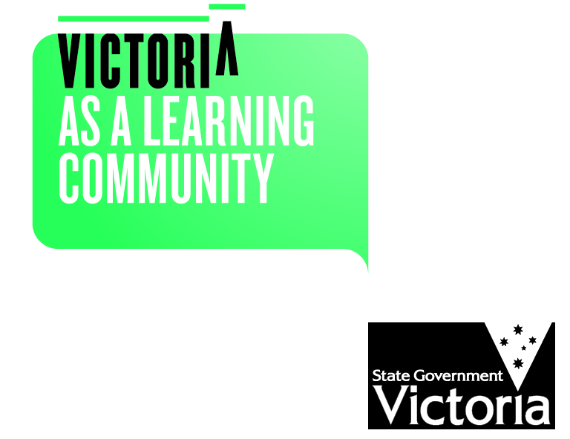
- Comply with and model school values.
- Behave in a safe and responsible manner.
- Respect ourselves, other members of the school community and the school environment.
- Actively participate in school.
- Not disrupt the learning of others and make the most of our educational opportunities.

As Community MEMBERS, We will:
- Model positive behaviour to the school community.
- Treat other members of the school community with respect.
- Support school staff to maintain a safe and orderly learning environment for all students.
- Utilise the school’s communications policy to communicate with the school.
THE DEPARMENT OF EDUCATION AND EARLY CHILDHOOD DEVELOPMENT WILL:
- Provide support and advice to principals to equip them to manage and respond to challenging behaviour of students, parents and staff.
- Provide practical guidance and resources to support schools to manage and respond to challenging behaviour of students, parents and staff.
- Provide practical guidance and resources to support schools respond to and prevent bullying and promote cyber-safety and wellbeing.
- Provide access to evidence based resources and strategies to increase student safety, wellbeing and engagement.
- Provide schools with practical and legal support as required.
- Provide parents with practical guidance and resources to resolve conflicts with the school.

consequences for failing to uphold the statement of values
Unreasonable behaviours
Behaviours that are considered inappropriate on and adjacent to school grounds or in relation to school business and that do not uphold the principles of this Statement of Values include when a person:
- is rude, aggressive or harasses others
- sends rude, confronting or threatening letters, emails or text messages
- is manipulative or threatening
- speaks in an aggressive tone, either in person or over the telephone
- makes sexist, racist or derogatory comments
- inappropriately uses social media as a forum to raise concerns/make complaints against the school
- is physically intimidating, e.g. standing very close.

Consequences
Principals are responsible for determining what constitutes reasonable and unreasonable behaviour.
Unreasonable behaviour and/or failure to uphold the principles of this Statement of Values may lead to further investigation and the implementation of appropriate consequences. This may include:
- utilising mediation and counselling services
- alternative communication strategies being applied
- formal notice preventing entry onto school premises or attendance at school activities. Written notice will follow any verbal notice given.
- an intervention order being sought
- informing the police which may result in a charge of trespass or assault
By agreeing to meet specified standards of positive behaviour, everyone in our school community can be assured that they will be treated with fairness and respect. In turn, this will help to create a school that is safe and orderly, where everyone is empowered to participate and learn.
Appendix 7

Wellbeing referral process


